**HURRICANE HARVEY DONATION DRIVE**

SENATOR ELAINE PHILLIPS, LOCAL VILLAGE MAYORS, AND ISLAND HARVEST ARE PARTNERING TO ASSIST THOSE AFFECTED BY HURRICANE HARVEY

***Here on Long Island, we know all too well of the devastation and destruction that major hurricanes, and their aftermath, can cause our families, homes, businesses, and communities. The thoughts and prayers of all New Yorkers are with our fellow Americans now coping with the unprecedented and catastrophic flooding caused by Hurricane Harvey.***

***The imagery coming out of southeastern Texas is heartbreaking, and although we are thousands of miles away, there are ways to help during this disaster.***

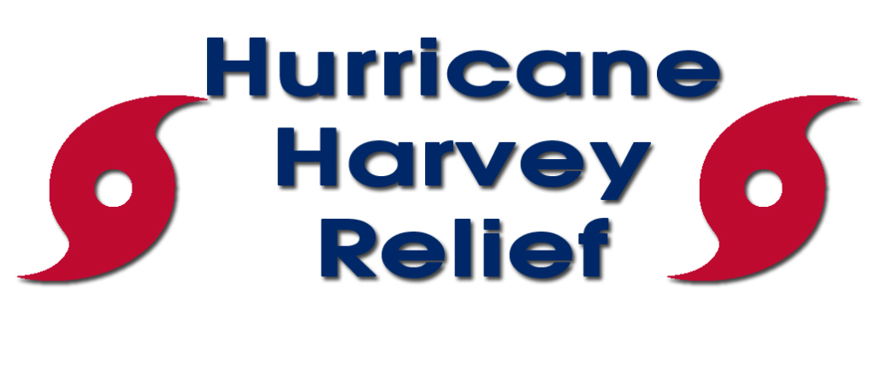***Please consider donating desperately needed goods to this donation drive.***

**DONATIONS MAY BE DROPPED OFF AT SENATOR PHILLIPS’ MINEOLA OFFICE OR AT ANY OF THE FOLLOWING VILLAGE OFFICES NOW THROUGH FRIDAY, SEPTEMBER 15**

Baxter Estates ▪ Bellerose ▪ East Hills ▪ East Williston ▪ Floral Park ▪ Flower Hill ▪ Great Neck

Great Neck Estates ▪ Great Neck Plaza ▪ Kensington ▪ Kings Point ▪ Lake Success

Manorhaven ▪ Mineola ▪ Munsey Park ▪ New Hyde Park ▪ North Hills ▪ Old Westbury

(Old Westbury Police Department if Village closed) ▪ Plandome ▪ Plandome Manor

Port Washington North ▪ Roslyn ▪ Roslyn Estates ▪ Roslyn Harbor ▪ Russell Gardens

Saddle Rock ▪ Sands Point ▪ South Floral Park ▪ Stewart Manor ▪ Thomaston

Westbury ▪ Williston Park

**MOST NEEDED ITEMS**

**Water Bottles, Non-Perishable Food And Shelf Stable Pantry Items (Peanut Butter, Tuna And Soup) Baby Food, Formula, And Diapers, Personal Hygiene Items (Toothbrushes, Toothpaste, Soap, Deodorant, Etc.), Cleaning Supplies (Bleach, Non-Bleach,**

**Paper Towels, Etc.)**

For those wishing to make monetary donations, please be sure you are donating to a reputable charity such as the American Red Cross, Salvation Army or Americares.