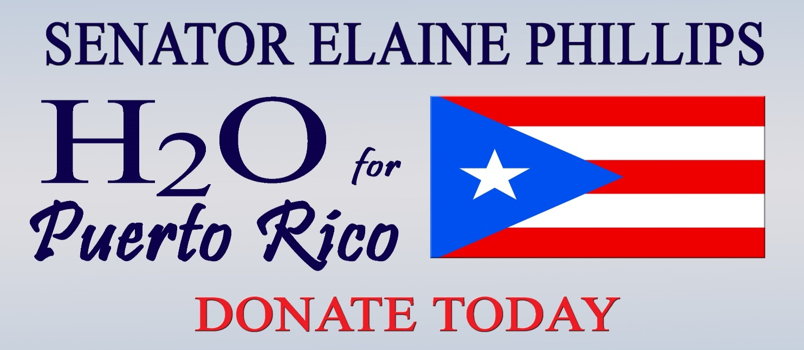

As Long Islanders we know first-hand the importance of safe drinking water and have made it our priority to protect our sole source water aquifers for future generations.Right now, millions of residents of Puerto Rico are in dire need of clean drinking water following the devastation from Hurricane Maria.My office is partnering with Long Island Cares for an “H2O for Puerto Rico campaign to collect bottled water for our fellow Americans.We are seeking donations of drinking water in any form: jugs, bottles, canned, etc.

**WATER DONATIONS MAY BE DROPPED OFF AT**

**FLOWER HILL VILLAGE HALL**

**1 BONNIE HEIGHTS ROAD**

**(CORNER OF PORT WASHINGTON BLVD.)**

**MON. – FRI., 8:30 AM TO 4:30 PM**

**OR SEND A DONATION BY GOING TO**

**https://yougivegoods.com/senatorelainephillips**

**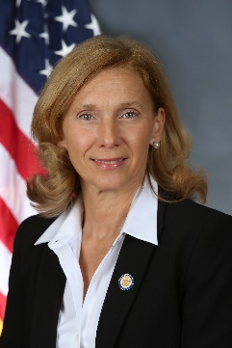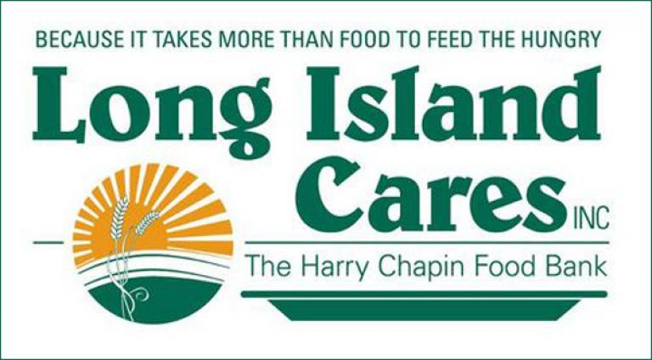*“From Our Island to Yours”***