Generic Description of Survey

The Nassau County Hazard Mitigation survey is 31 questions long and should take no more than 15 minutes to complete. You will be asked about hazards that concern you, your experiences with disasters, and how you think Nassau County should respond to future disasters. Your feedback will make Nassau County more prepared!

This is the link to the survey: <https://www.surveymonkey.com/r/NassauHazards>

This is a QR code. When people scan it with their phone cameras, it will take them directly to the survey.

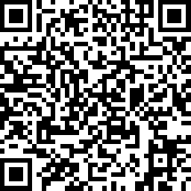

Generic Social Media Posts

*These options are designed for a longer form social media site or relevant group run by the County, such as a Facebook page or Instagram account. Nassau County also has a dedicated* [*reddit page*](https://www.reddit.com/r/nassaucounty/)*, which contains only people who want to hear news about Nassau County and is moderated by volunteers. This would be a great place to advertise the survey as well.*

## Option I

This is [NAME]. S/he’s been a [firefighter / paramedic / emergency manager / other] here in [TOWN] for [X] years, so she knows a lot about [handling fire / helping the community / emergency management / other]. One thing s/he doesn’t know, though – what matters to you! Fill out the [Hazard Mitigation Survey](https://www.surveymonkey.com/r/NassauHazards) today to make sure your voice is heard.

*Even better if you can include a picture!*

## Option II

We can’t always predict natural disasters, but we can plan for them. Tell us which hazards you worry about, what you want Nassau County to focus on, and how you want the county to respond after a disaster with [Nassau County’s Hazard Mitigation Survey](https://www.surveymonkey.com/r/NassauHazards).

Don’t have too much time? No worries! You can opt out of longer questions as you take the survey. Lots of thoughts? No problem! The survey has open-ended responses where you can tell us everything you want, and it will give you the contact information of Nassau County officials who can help you further. If you live in Nassau County, we want to hear your opinion!

## Option III

Five years ago, few people predicted the COVID-19 pandemic, but with your help, we can start preparing for the next disaster today. Take the [Nassau County Hazard Mitigation Survey](https://www.surveymonkey.com/r/NassauHazards) and tell us how you want your community to respond to disasters.

## Option IV

Your opinion matters! Tell us about it on the Hazard Mitigation Survey. We will use your responses to improve our hazard planning and better serve our citizens during disasters. The survey is short and easy to take. Follow this [link](https://www.surveymonkey.com/r/NassauHazards) and tell us your vision for Nassau County’s future.

Twitter

*Twitter is a social media platform with a hard cap of 280 characters, including urls and spaces, per post. The URL should automatically shorten when you copy the whole post into twitter. The character count of each potential post is in parenthesis.*

## Option I

Has lockdown got you taking quizzes to find out [which Disney Princess you are](https://www.buzzfeed.com/mccarricksean/which-disney-princes-are-you) or [how much you like pasta](https://www.buzzfeed.com/frida8/how-many-varieties-of-pasta-have-you-tasted-2w9cd)? If so, you probably also have time to take the Hazard Mitigation Survey. [*https://www.surveymonkey.com/r/NassauHazards*](https://www.surveymonkey.com/r/NassauHazards)

(211 characters)

## Option II

Bored of scrolling through twitter? Scroll through Nassau County’s Hazard Mitigation Survey instead! [*https://www.surveymonkey.com/r/NassauHazards*](https://www.surveymonkey.com/r/NassauHazards)

(133 characters)

## Option III

#AreYouReady … to take the Nassau County Hazard Mitigation Survey? Because we are #ready to hear your answers! [*https://www.surveymonkey.com/r/NassauHazards*](https://www.surveymonkey.com/r/NassauHazards)

(143 characters)

## Option IV

Tell us what hazards scare you the most on our Hazard Mitigation Survey. Tweet @NassauOEM when you finish and retweet so your friends can take the survey too.[*https://www.surveymonkey.com/r/NassauHazards*](https://www.surveymonkey.com/r/NassauHazards)

(190 characters)

## Option V

Got #2020vision? Put it to good use on the Nassau County Hazard Mitigation Survey. [*https://www.surveymonkey.com/r/NassauHazards*](https://www.surveymonkey.com/r/NassauHazards)

(115 characters)

## Option VI

#TBT to when Nassau County got 30 inches of snow overnight in January. Help us prepare for the next big snowstorm by taking our Hazard Mitigation Survey. [*https://www.surveymonkey.com/r/NassauHazards*](https://www.surveymonkey.com/r/NassauHazards)

(186 characters)

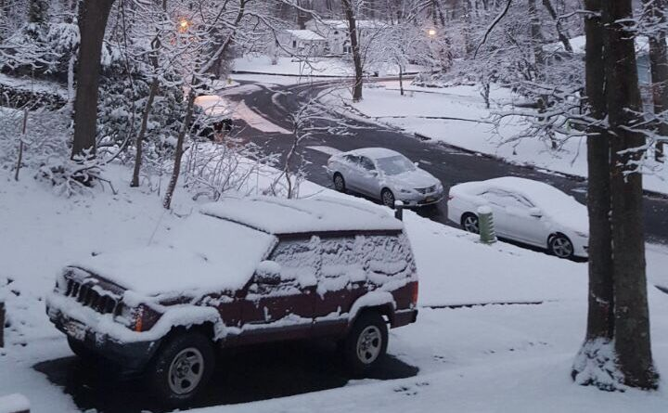

*(you might have more relevant pictures from the January 2020 snowstorm)*

*Note: TBT stands for Throwback Thursday, so this tweet should be posted on a Thursday.*

Images

*Social Media posts tend to gain more traction when they have an image attached. Consider including a logo or some pictures from your files of emergency managers hard at work.*